Member database

To use the database, you need to download all these files in the folder, which are shown in the figure 1 below.

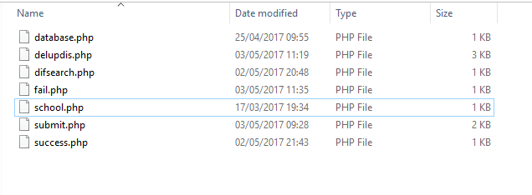

Figure

The main files are delupdis.php and submit.php. The database.php, difserch.php and success.php files are included in the delupdis.php.

When the user presses the submit button, in submit.php, they will be redirected to the success.php if the data was successful admitted and not they will be redirected to fail.php file.

From the success.php and fail.php files, there are two options, which are going back to submit.php or to delupdis.php.

In the delupdis.php file, there are four options including home, update, delete and filter.

The figure 2 below is showing the confirmation message in the delupdis.php, before updating data in the table.

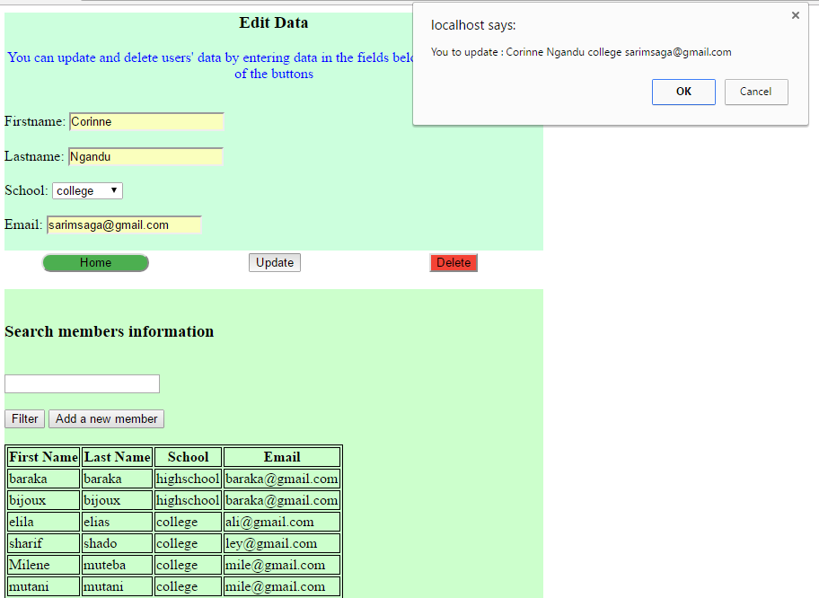

Figure

The figure 3 below is showing the warming message in the delupdis.php, before deleting the information.

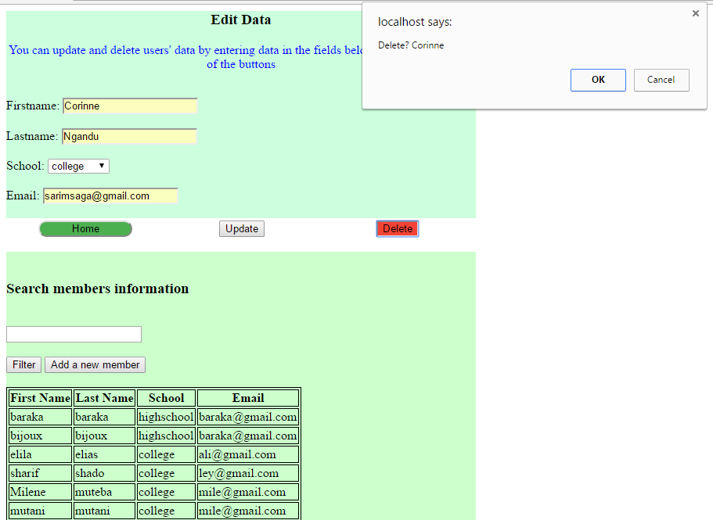

Figure

The figure 4 below is the success.php file



Figure

The figure 5 below is the fail.php file.

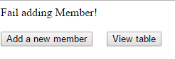

Figure